

ISOC Contribution to World Telecommunication Policy Forum:
Comments on the Secretary General’s Report

22 April 2009

Following the last meeting of the World Telecommunication Policy Forum (WTPF) Informal Expert Group held on the 24th of June, we have prepared additional comments on the Secretary General’s Report, and on the Opinions that are presented in its annexes.

As a member of the Informal Expert Group to the WTPF, the Internet Society has been actively engaged in the past year in preparations for this multi-stakeholder event. As a preliminary remark, we would like to emphasize that following the ITU Secretariat General’s request in June 2008, ISOC submitted a proposal of a selected topic related to Convergence and Emerging policy issues. ISOC wished on that occasion to voice support for the direction of many comments made several times in the development of the drafts of the Secretary General’s Report and subsequent discussion: specifically that the WTPF would have been more useful and effective if it had narrowed its focus to one or two pressing issues being faced by the world community.

ISOC supported focusing on Green ICT or ICT and Public Safety, and this proposal was developed with supporting material. We welcome that one of the proposed Opinions addresses specifically “ICT and the Environment”, however we regret that none of the Working Groups of the Forum will be exclusively focusing on this critical and emerging issue.

Ultimately, it was decided that the WTPF would focus on a broad range of topics that require solid technical expertise, such as Convergence including Internet-related public policy matters, Emerging Telecommunication policy and regulatory issues, Next Generation Networks (NGNs) and International Telecommunication Regulations.

In this challenging context, ISOC values the opportunity for a multi-stakeholder dialogue, within the IEG and at the upcoming Forum, and the opportunity to provide factual and technical information in the hope that the discussions in Lisbon will be constructive, and informed.

The Internet Society takes note of the Opinions that now form a part of the Secretary-General’s Report to the WTPF, and looks forward to the opportunity to engage in fuller discussion of these matters during the Lisbon event. As a general comment on the Opinions, we would like to stress the importance of respecting and protecting the Internet model which continues to underpin the Internet’s contribution to innovation and creativity. The Internet Model is based on widely supported key principles, such as the "end-to-end principle," which supports the global deployment of innovative, and often surprising applications. The openness and transparency of the Internet's technical development, along with its associated policy development and management processes, are intrinsic to the success of the Internet itself, and to maintaining the global Internet.

The Internet's development has always depended upon openness to broad and diverse inputs. This is essential, as the Internet is a platform on which organizations and all types of users themselves build the infrastructure, software and services that then become globally accessible. As the Internet grows and continues to spur economic and social development around the world, the policies and practices of tomorrow must grow from the shared principles and the shared vision that gave us the Internet.

This global platform has enabled an unprecedented scale of human communications, revolutionized how we express ourselves and collaborate, and in so doing has already contributed unimaginably to the well being of citizens around the world. However, for ICT to continue to contribute to the wellbeing of all citizens around the world, we all must work to ensure that people have unfettered, affordable access to the network, whether from PC's, phones or other devices, and can choose from a diversity of suppliers, services, applications, and products. The communications environment must not be encumbered by excessive governmental or private controls. The services and applications on the Internet must be trusted, reliable, and stable, and the user's identity must be sacrosanct.

Effectively, the Internet thrives, and its contribution to society is greatest, when conditions ensure that users have the ability to freely connect, to communicate, to innovate, to share, to choose and to trust. To understand why these abilities are so important, we must recognize that technologies and infrastructure are required for progress, but do not drive progress. People drive progress. Their needs and the opportunities they see, drive applications, solutions and innovations.

It is easy to make the mistake of talking about how the Internet was developed. The Internet is still developing. It is essential to heed the lessons of its short history. The Internet’s future development should be restricted only by our imaginations. The genius of the Internet is that its decentralized architecture maximizes the power of individual users to choose (or create) the hardware, software, and services that best meet their needs. If the Internet is to continue to be a platform for innovation and creativity, its open, globally addressable, decentralized nature must be preserved.

The deliberations that we look forward to in Lisbon take place in a challenging economic environment. To address those challenges, it is vital to preserve the conditions that sustain Internet development. Only in that way can the Internet continue to help sustain the world’s progress and development.

To promote understanding of these key points, the Internet Society submited information documents on “The Internet Ecosystem” and “Preserving the User Centric Internet”. We also provided fact sheets on “IPv6 Address Allocation”, “The Internet and Standards” and “NGN and the Internet” as official background papers to the 2009 World Telecommunication Policy Forum. These factual papers have been elaborated by the Internet Society’s Standards and Technology department. We hope that the information provided in these documents (cf. Annexes 1 to 5) will be used by delegations to inform discussions in Lisbon.

Finally, we’d like to thank the ITU for inviting sector member to participate to the discussions of the World Telecommunication Policy Forum. We would like to encourage the ITU Secretariat General to continue opening its conferences to all interested stakeholders, and broadening participation, beyond its Member States and Sector Members, to the Civil Society, the Internet community and the research community. We strongly believe there is an overarching need to develop appropriate multi-stakeholder forums that involve knowledgeable, interested and capable people in crafting solutions that enhance the strength of the Internet as a vital tool for communication and innovation.

We look forward discussing these comments at the World Telecommunication Policy Forum in Lisbon.

About the Internet Society

The Internet Society (ISOC) is an independent international nonprofit organization with headquarters in Geneva, Switzerland and Reston, Virginia, USA. ISOC acts as a global clearinghouse for technically-sound, unbiased information about the Internet, as a provider of education, and also as a facilitator and coordinator of Internet-related initiatives around the world. It provides the organizational home for the IETF, IAB and IRTF.
ISOC was founded in 1992 to provide leadership in Internet related standards, education, and policy. It is supported by an active, global network of members who help promote and pursue the ISOC mission in all parts of the Internet community and all parts of the world. The Society has more than 80 organizational and more than 28,000 individual members in over 80 chapters who contribute to regionalizing the scope of ISOC technical, educational and policy initiatives. ISOC is a Sector Member of ITU–T (Standards) and ITU-D (Development) since 1995. The website is: http://www.isoc.org.
Annexe 1
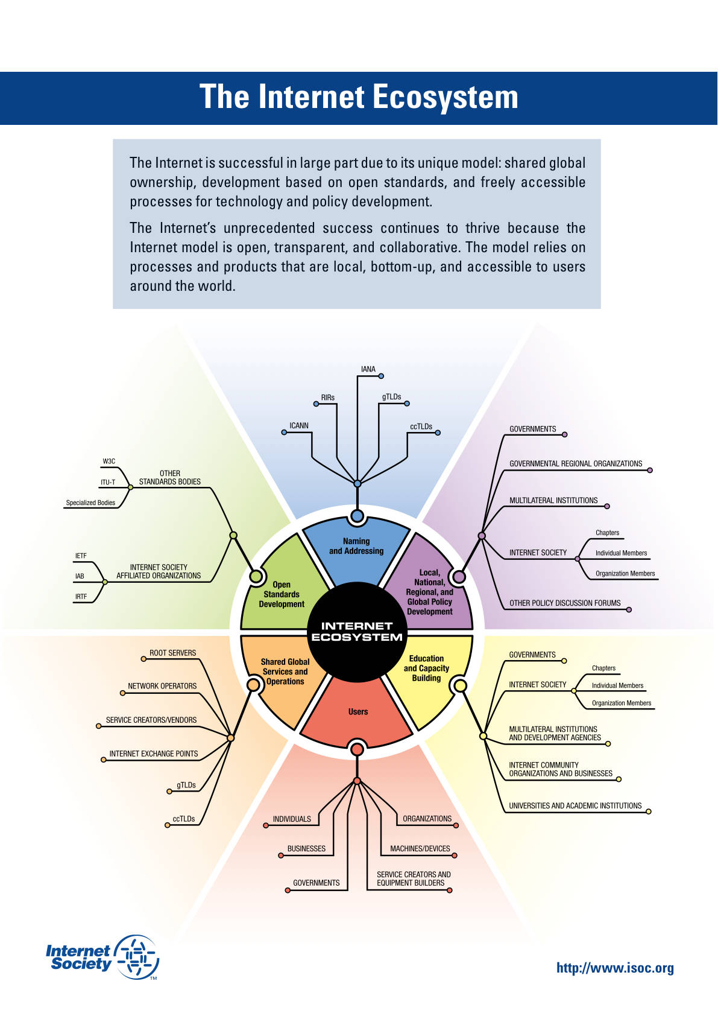
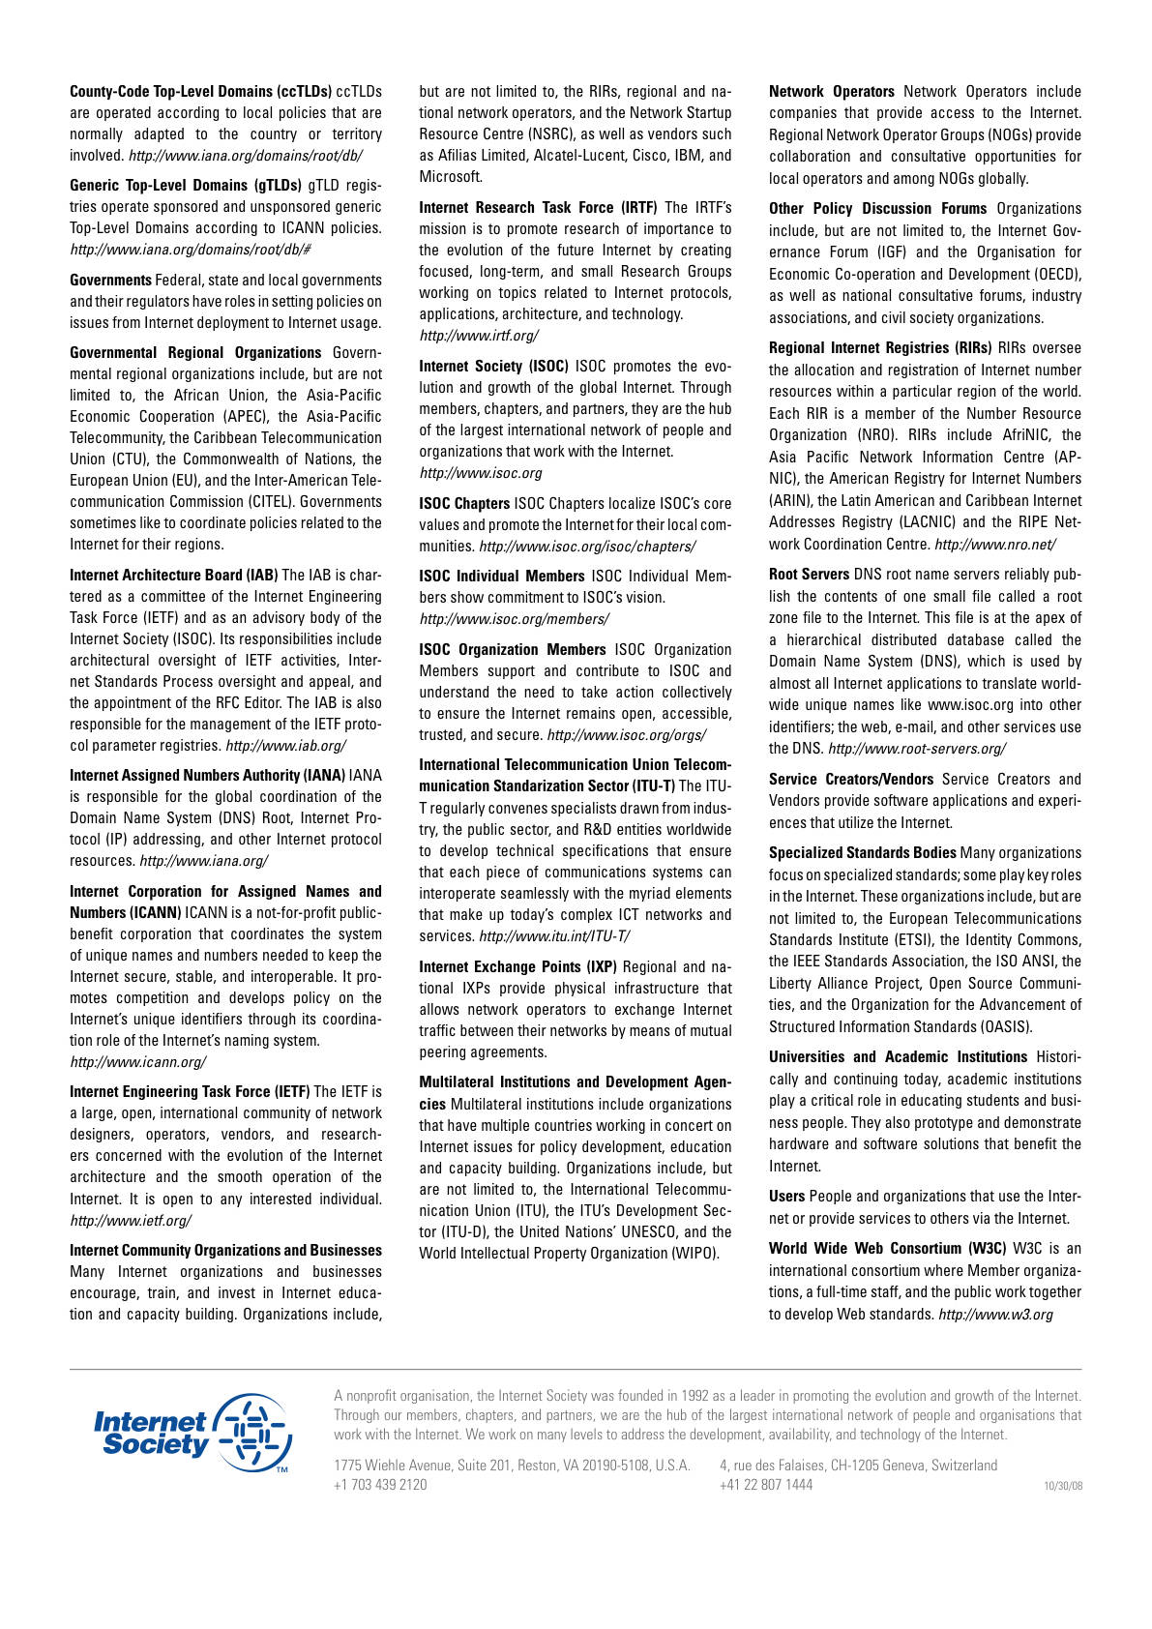
Annexe 2

ISOC Contribution to World Telecommunication Policy Forum:
Preserving the User Centric Internet

22 April, 2009

ABOUT THIS PAPER

This paper, Preserving the User Centric Internet, was developed by the Internet Society in 2007. It is intended to clarify for readers the importance of the design values and fundamental principles that have underpinned the Internet's success. The Internet Society believes that principles such as openness, user choice and control, and edge based intelligence, among others, are central to a thriving Internet and, we believe, will be so for the foreseeable future. In focusing on "user-centricity", ISOC is seeking to ensure that the primacy of the user is not forgotten when it comes to new architectures, commercial offerings and policy making. We believe that an understanding of the issues raised in this paper remain relevant, and should underlie discussions of Internet public policy issues expected to take place at the 2009 World Telecommunication Policy Forum.

The Internet today faces a range of challenges that could impact the distributed, end-to-end and open nature that users have come to take for granted. Some of these challenges are service and architecture related, including but not limited to the Network Neutrality debate in the United States, initiatives on Next Generation Networks, and the discussion in Europe and elsewhere over the future of access regulation (unbundling) and competition. Other challenges relate to the impact changes in Internet usage patterns and the explosion of content consumption and creation are having on Internet architecture and business models.

These challenges are, in many ways, born of the Internet’s success. This “network of networks” is enjoyed and shaped by an increasingly diverse range of players, from its users, to those who manage the networks that comprise it, to nations whose economic competitive advantage increasingly depends upon it. The Internet has shown itself to be supremely flexible and adaptable; yet these growing commercial and economic challenges apply pressures that could well change some of the principal elements underlying its success.

The Internet Society (ISOC) believes that the Internet’s future depends on a renewed commitment to the principles that have made it so successful to date. For each of the various challenges listed, ISOC is concerned that there has been insufficient focus on the imperative of ensuring that the fundamental user-focused principles that the Internet is built upon are preserved. The National Academies voiced their concern in this regard in their 2001 publication “The Internet’s Coming of Age”:
The design values of the Internet have been reinforced by the environment in which the Internet was developed. In its early years as a cooperative research project, it was isolated from some of the stresses and strains associated with commercial marketplace interactions. …. Whether and how the traditional Internet design values will be maintained is an important issue for the future of the Internet.
The importance of maintaining these design values, and the fundamental principles that are based upon them, is at the heart of the Internet Society’s “User Centric Internet, an initiative that calls for a renewed focus on the openness, transparency, edge-based intelligence and, above all, user choice that are at the heart of the Internet today”.

I. The changing Internet

The success of the Internet has been due in large part to a common understanding or compact that the Internet and the fundamental benefits that arise from the Internet model are good for all. As Daniel Weitzner at MIT and W3C describes it:

The neutrality of the Internet arises out of a combination of basic architectural features of Internet and World Wide Web standards, and business practices on the retail and back-end of Internet service provider networks, all in a delicate balance with the competitive market forces that tie service providers, technology developers, and content providers together in a global, voluntary agreement to maintain these practices and standards. This agreement has been maintained out of an implicit but shared belief that cooperation to keep the Internet functioning as an open, interconnected and non-discriminatory platform serves the interests of the parties individually, as well as collectively.

However, this common benefit and “delicate balance” that has stood the test of time so well is now threatened by its very success.

The Internet is mainstream – it is no longer different or special. What is clear is that the ubiquity and indispensability of the Internet have made it an important means of reaching customers and building business opportunity. One of the consequences of the Internet’s success is the desire to exploit it for business and competitive advantage. This in turn could have a significant impact on shaping the Internet’s architecture, on the way commercial offerings are structured and on the way in which the Internet is used.

One of the characteristics of the Internet experience to date has been relatively unconstrained access for reasonable cost. Yet, the days of the Internet “all the bandwidth you can consume” buffet appear to be under threat. Some suggest that the commoditization of Internet access has limited the ability of service providers to compete and invest in new networks, and is forcing them to find new business models and new ways of leveraging their assets. Content for example, may well become an increasing differentiation characteristic of service offerings, with providers creating new subscription packages that the Internet user can then choose to purchase or not (not dissimilar to the cable model). But, how will evolving subscription packages impact user choice? To what degree will they shape the users’ Internet experience? The traditional content business is based upon proprietary product and premium content, much of which is increasingly tailored to particular groups of consumers. Will users who are already downloading movies, music, sharing video, and other multimedia pay more for the services they are already accessing? Undoubtedly there will be significant changes in commercial offerings that are based upon or tie into Internet access. Whether they be content focused, metered or Service Level Agreement based, innovation in commercial offerings should not be constrained. That said, at the same time it is important that there is adequate competition in service offerings and that there is a continuing ability for users to exercise choice in that regard. Further, while accessing content is an increasingly important part of a user’s experience, they should also be able to “use” the Internet in ways in which they are accustomed. While it is a somewhat artificial distinction, it is important that future commercial offerings ensure that Internet is available as a tool (for use) as well as another medium for viewing content.

The future of the Internet is also being shaped by other factors, ranging from changing industry structure to questions related to the sustainability of the Internet given demands on the existing architecture. These factors also are having a direct impact on the user through affecting their ability to choose, inter alia, the service provider and the Internet service subscription of their choice.

Around the globe the traditional communications environment is changing with likely implications for the future of the Internet. In the United States, significant market restructuring is resulting in far greater consolidated local and backbone/transit footprints than before, lessening the dependencies on Weitzner’s compact mentioned above. How this will impact the competitive landscape remains to be seen. In Europe, there is a considerable debate over the desirability of continued access regulation such as local loop unbundling, particularly with regards to new infrastructure investment. As the communications landscape changes around the globe, what is clear is that a user’s ability to choose among providers is as important as, and has a direct bearing on, their ability to choose among subscription and service packages. User choice is dependent upon flourishing competition, so low barriers to market entry, not only in terms of infrastructure investment, but also content provisioning and user-driven innovation, is essential.

There are also wide-ranging discussions about the future viability of an Internet based on “best effort” delivery. One of the defining characteristics of the Internet is that it is a truly two-way, interactive medium driven by users (individual and community) innovation and creativity. This interactivity, and the ability of users to create content and applications, is driving an unprecedented explosion of user-created content and content sharing. This is not without its consequences, one of which is the suggestion that the networks underpinning the Internet are under increasing strain as more Internet users come on line and the availability and generation of content continues. Typical network based responses would include QoS management and/or bandwidth provisioning. One of the concerns expressed in this regard is whether the user’s Internet subscription will be increasingly determined by network management or by traffic type. For example, will services such as HDTV, DVD quality streaming and other high-bandwidth services become part of “premium content” packages that mirror some of the cable business offerings? And if services are broken out by particular characteristics, will those characterized by latency and jitter intolerance for example be priced higher to deliver?

Some look to architectural solutions, with next generation networks promising feature-rich triple or quadruple play converged services, in which quality-of-service (QoS) is ensured, security enhanced and application and service management made simpler. Concerns have been raised that such architectures could remove the control from the user and the intelligence from the edge, and place them once again into the core of the network. The focus in these multiple-play architectures is also largely on the consumption of content – but how will they facilitate and encourage its creation? Does the future of networking lie in the struggle between two different worlds, that of the Internet model, with its associated openness and freedom and user-centricity, on the one hand, and the closed network model, in which choice and control no longer sits with the user, on the other?

Whatever the future of commercial offerings and network architecture, how the Internet user will benefit and how user-centricity will be preserved should be the yardstick by which they are measured.

II. The importance of choice

Today’s Internet is a user centric focused network of networks. It is, to paraphrase the Federal Communications Commission, the user who decides (largely) the content they wish to access, the applications they wish to use, the devices they wish to attach to the network and the service type or subscription package they wish to acquire. In each case the user makes choices and they have a set of options to choose from. This issue of choice (and the control that goes hand in hand with it) is fundamental to the user-centricity of the Internet.

Vint Cerf, Chief Internet Evangelist at Google, captured it well when he said:

The Internet's open, neutral architecture has proven to be an enormous engine for market innovation, economic growth, social discourse, and the free flow of ideas. The remarkable success of the Internet can be traced to a few simple network principles - end-to-end design, layered architecture, and open standards -- which together give consumers choice and control over their online activities.

A central issue to the Internet Society’s focus on the User Centric Internet is the degree to which today’s Internet user will have the same “choice and control over their online activities” in the future.

The issue of choice was touched upon briefly above with regards to service offerings and access provision. Yet it is much broader in its importance: users expect to be able to use the Internet as they wish, accessing the people, sites and content of their choice – recognizing that they might be limited by what is legal/illegal and what may not be accessible for technical reasons. At the moment that user experience is largely unconstrained.

One concern that has arisen is whether, with changing business models on the Internet, we are moving, or being moved, from users to consumers. And with that possible change does the Internet start to lose its user centricity and the users their control over this incredible tool? One of the unintended consequences of such a change could be a lessening of the innovation that is a result of not only the Internet’s architecture but also its openness and accessibility. Innovation on the Internet has been driven by the user, by the individual, the entrepreneur, by the small business, by the corporation. The nature of the Internet, its ubiquity, openness and simplicity has enabled businesses to be built, communities to be formed, content to be created. How would these have been possible without the ability of the user to leverage the Internet as we know it today? How will the user’s ability to wield this tool, for innovation for example, be different in the future?

This fundamental dynamic of choice is what has driven blogging, social networking, VoIP, and other innovations on the Internet. This user-centricity has unleashed innovation in communities, businesses, garage start-ups, and college dorm rooms. The ability to exploit the medium in an unfettered way has been a driver of its success. It is easy to forget that the Internet is more than a network of networks – rather it is a medium and tool that unleashes user creativity and innovation, and that builds communities and human and institutional networks around the globe, and drives commerce in unprecedented ways.

III. The future of the User Centric Internet

The Internet of today has been shaped by the fundamental principle that the user is in charge of their online activities: today’s users choose and control where they wish to go on the Internet, who they wish to communicate with, the content and communities they wish to access, and the applications they wish to use. And most importantly, the intelligent edge and user centricity have driven innovation, the digital economy, the Information society, while measurably contributing to the wealth of nations. The Internet Society believes that these characteristics have made the Internet a unique tool, and a users’ ability to wield this tool should not be fettered.

The Internet Society believes that the debate over issues such as network neutrality rules masks a more important discussion related to the future of the user centricity of the Internet and the preservation of the underlying principles that have made it the success that it is today. This is a discussion that merits much greater consideration as it has a direct bearing on the way the Internet will evolve. For example, the user-centricity of the future Internet depends on how we answer some fundamental yet complex questions, including:

- How do we maintain and improve upon the user-defined experience that has driven the overwhelming success of the Internet while encouraging investment and innovation, new services, new content, and other benefits yet unforeseen?

- As the Internet also becomes a significant medium for the provision and consumption of content, how can its fundamental interactivity be preserved so that its use as a tool for human creativity remains as compelling as ever? How does the user remain a user as well as a consumer?

- Will the Internet of the future be accessible and open as a result of new investment, new networks and new business models or will the new networks be closed, tiered and exclusive, carrying only certain content to certain subscribers?

These are not easy issues to balance, but the Internet Society believes that the guiding principles for decision making must be the preservation of the Internet’s user-centricity through its design values and its principles of openness, transparency, edge-based intelligence and, above all, user choice. Architectures, business models, and policies that fundamentally shift away from these design values are fundamentally shifting away from the Internet itself. Ensuring innovation, investment and commercial opportunity along with continued and enhanced user centricity will be essential to the Internet’s future success.

IV. The Internet Society

The Internet Society (ISOC) is an independent international nonprofit organization with headquarters in Geneva, Switzerland and Reston, Virginia, USA. ISOC acts as a global clearinghouse for technically-sound, unbiased information about the Internet, as a provider of education, and also as a facilitator and coordinator of Internet-related initiatives around the world. It provides the organizational home for the IETF, IAB and IRTF.

ISOC was founded in 1992 to provide leadership in Internet related standards, education, and policy. It is supported by an active, global network of members who help promote and pursue the ISOC mission in all parts of the Internet community and all parts of the world. The Society has more than 80 organizational and more than 28,000 individual members in over 80 chapters who contribute to regionalizing the scope of ISOC technical, educational and policy initiatives.

ISOC is a Sector Member of ITU–T (Standards) and ITU-D (Development) since 1995. The website is: http://www.isoc.org.

Annexe 3

ISOC Contribution to World Telecommunication Policy Forum:
IPv6 Address Allocation

22 April 2009

I. Introduction

The growth and success of the Internet continues to depend on collaboratively engineered and operated, robust technical infrastructure. The Internet Society is pleased to offer the following factual information to provide an overview of the organizations carrying out strategic roles in the development and deployment of IPv6. We hope it will inform discussions and be helpful to those seeking accurate information on IPv6 deployment in the various regions of the world or who would like to find contacts to help them address particular concerns they have in their region.

II. Internet Number Allocation and Policy

The five Regional Internet Registries (RIRs) oversee the allocation and assignment of Internet number resources in the various regions of the world. More information about the RIR structure can be found at http://www.isoc.org/briefings/021/ .

The RIRs set policies by working together openly with their constituencies in their regions, including interested governments, to assure equitable treatment of number resources as well as policies for other aspects of network operations. All of them are active in supporting the deployment of IPv6 and maintain resources to facilitate economies in their regions in their own deployments of IPv6. They are listed here by region with pointers to their online resources and information about their next meetings.

a. Africa

AfriNIC is the Regional Internet Registry serving Africa. Their website is at: http://www.afrinic.net. “AfriNIC is a non-government, not-for-profit, membership based organization, based in Mauritius to serve African Internet Community. AfriNIC is the Regional Registry for Internet Number Resources for Africa. Membership is open to anybody.” AfriNIC is an Associate Member of the ITU, in the category of Regional and other International Organizations. They have an IPv6 resource center online with lots of accurate information about IPv6 deployment here: http://www.afrinic.net/IPv6/index.htm. AfriNIC is holding its next public policy meeting (AfriNIC-10) in Cairo, Egypt from 18-22 May, 2009, with an IPv6 workshop on 16 and 17 May.

b. Asia-Pacific

APNIC is the Regional Internet Registry serving the Asia-Pacific region. Their website is at: http://www.apnic.net. “APNIC is one of five Regional Internet Registries currently operating in the world. It provides allocation and registration services which support the operation of the Internet globally. It is a not-for-profit, membership-based organisation whose members include Internet Service Providers, National Internet Registries, and similar organisations. APNIC represents the Asia Pacific region, comprising 56 economies.” APNIC is an Associate Member of the ITU, in the category of Regional and other International Organizations. They have an IPv6 resource center online with lots of accurate information about IPv6 deployment at: http://www.apnic.net/services/ipv6_guide.html. APNIC is holding its next public policy meeting APNIC-28 in Beijing, China from 22-29 August, 2009.

c. Europe and the Middle East

RIPE NCC is the Regional Internet Registry serving Europe, the Middle East, and parts of Central Asia. Their website is here: http://www.ripe.net. “The RIPE NCC is an independent, not-for-profit membership organisation that supports the infrastructure of the Internet through technical co-ordination in its service region. The most prominent activity of the RIPE NCC is to act as the Regional Internet Registry (RIR) providing global Internet resources and related services (IPv4, IPv6 and AS Number resources) to members in the RIPE NCC service region. The membership consists mainly of Internet Service Providers (ISPs), telecommunication organisations and large corporations located in Europe, the Middle East and parts of Central Asia.” They have lots of accurate information about IPv6 deployment at: http://www.ripe.net/rs/ipv6/index.html. The next RIPE NCC meeting (RIPE-58) will be held in Amsterdam from 4-8 May, 2009.

d. Latin America

LACNIC is the Regional Internet Registry serving Latin America and the Caribbean region. Their website is at: http://www.lacnic.net. “LACNIC is an international non-profit organization established in October 2002 with headquarters in Uruguay. It is managed by a Board of Directors consisting of six members elected by member organizations.” They have an IPv6 Information Center with pointers to accurate information about IPv6 deployment here: http://www.lacnic.net/ipv6/en/. LACNIC will be holding its next meeting from 25-29 May, 2009, in Panama City, Panama.

e. North America

ARIN is the Regional Internet Registry for North America. Their website is here: http://www.arin.net. “Applying the principles of stewardship, ARIN, a non-profit corporation, allocates Internet Protocol resources; develops consensus-based policies; and facilitates the advancement of the Internet through information and educational outreach.” ARIN maintains an IPv6 information center with lots of useful information about IPv6 at: http://www.arin.net/v6/v6-info.html and an IPv6 Wiki page at: http://www.getipv6.info/index.php/Main_Page . The next ARIN meeting will be held in San Antonio, Texas from 26-29 April 2009.

f. The Number Resource Organization (NRO)

The Regional Internet Registries formed the NRO is 2003 to formalize their cooperative efforts. The NRO exists to protect the unallocated IP number resource pool, the bottom up policy development process, and act as a focal point for community input to the RIR process. They maintain a website at: http://www.nro.net.

III. Internet Number Assignment

The Internet Assigned Numbers Authority (IANA), which is currently carried out under contract by the Internet Corporation for Assigned Names and Numbers (ICANN), manages the allocation and maintenance of unique codes and numbers. ICANN is an internationally-organised non-profit organisation set up by the Internet community to help coordinate IANA's areas of responsibilities. The IANA contract does not directly set the policies by which it operates. Instead it provides for implementing agreed policies and principles in a neutral and responsible manner, relying on the policy setting forums provided by ICANN. Policy development for domain name operations and IP addressing is arrived at by many different stakeholders, including governments, through ICANN’s structure of supporting organisations that contribute to deciding how ICANN runs, and in turn how the IANA functions develop. Those involved in the IANA function are actively involved in outreach, not only through ICANN forums, but also through participation in meetings and discussions with TLD operators, Regional Internet Registries, and other relevant communities. They maintain a website at: http://www.iana.org.

IV. Standards

The development of Internet protocols, which often dictate how protocol assignments should be managed, are arrived at within the Internet Engineering Task Force (IETF), with guidance from the Internet Architecture Board (IAB), through an open, transparent, bottom-up process open to all interested expert stakeholders. Their websites are at: http://www.ietf.org and http://www.iab.org.

Over the past 15 years the IETF has developed the standards that define IPv6. There are on-going working group activities to define operational best practices as well as refinements of ancillary protocols. Working group activity is carried out continuously via electronic mailing list discussion, and during regularly scheduled IETF meetings. The next plenary face to face meeting of IETF engineers will be in Stockholm, from 26-31 July 2009. The details of that meeting are here: http://www.ietf.org/meetings/75 .

V. Operations

There are a number of operational meetings around the world where network operators come together to discuss aspects of the operations of their respective networks within the Internet. These include such organizations as AfNOG, the African Network Operators Group (http://www.afnog.org), NANOG, the North American Network Operators Group (http://www.nanog.org), APRICOT, the Asia Pacific Regional Internet Conference on Operational Technologies (http://www.apricot.net), MENOG, the Middle East Network Operators Group (http://www.menog.net), SANOG, the South Asian Network Operators Group (http://www.sanog.org), and PacNOG, the Pacific Region Network Operators Group (http://www.pacnog.org).

VI. The Internet Society

The Internet Society (ISOC) is an independent international nonprofit organization with headquarters in Geneva, Switzerland and Reston, Virginia, USA. ISOC acts as a global clearinghouse for technically-sound, unbiased information about the Internet, as a provider of education, and also as a facilitator and coordinator of Internet-related initiatives around the world. It provides the organizational home for the IETF, IAB and IRTF.

ISOC was founded in 1992 to provide leadership in Internet related standards, education, and policy. It is supported by an active, global network of members who help promote and pursue the ISOC mission in all parts of the Internet community and all parts of the world. The Society has more than 80 organizational and more than 28,000 individual members in over 80 chapters who contribute to regionalizing the scope of ISOC technical, educational and policy initiatives.

ISOC is a Sector Member of ITU–T (Standards) and ITU-D (Development) since 1995. The website is: http://www.isoc.org. Useful information about IPv6 can be found at: http://www.isoc.org/educpillar/resources/ipv6.shtml.

Annexe 4

ISOC Contribution to World Telecommunication Policy Forum:
The Internet and Standards

22 April 2009

The Internet is built on technical standards, which allow devices, services, and applications to be interoperable across a wide and disperse network of networks.

ISOC is the organisational home of the Internet Engineering Task Force (IETF), the Internet Architecture Board (IAB), the Internet Engineering Steering Group (IESG), and the Internet Research Task Force (IRTF). Collectively, these bodies support the creation of specifications and research for general Internet operation and evolution. The IETF and IRTF are open organisations, relying on transparent, bottom-up processes to build consensus. Thousands of people from around the world participate in the process and the standards they develop are free and accessible to everyone. Participants, who primarily come from the private sector, governments and academia, are technical experts who work together collaboratively as volunteers.

Many other organizations develop standards and technologies that play key roles in supporting the Internet or making use of the Internet. These organizations include, but are not limited to, the World Wide Web Consortium (W3C), the IEEE Standards Association, the ISO ANSI, the European Telecommunications Standards Institute (ETSI), the ITU-T, the Liberty Alliance Project, Open Source Communities, and the Organization for the Advancement of Structured Information Standards (OASIS).

This document is focused on the open standards that provide the general basis for the common Internet.

I. The Internet and Standards

The Internet was built on the premise of interoperability based on independent implementations of common specifications: Internet standards. By focusing on interoperability for passing traffic between networks, Internet standards describe the protocols on the wire without prescribing device characteristics, business models, or content.

The value of this building block approach is seen in the range and depth of innovation and development in Internet technologies and services. New components – whether networks, services or software – work seamlessly with existing deployments, as long as all pieces correctly implement applicable standards on the network. This makes the field of possible innovations virtually limitless.

II. Key characteristics of Internet standards

Apart from the focus on wire protocols for interoperability, successful Internet standards share certain characteristics, described below:

Freely accessible specifications: all relevant written specifications required to implement the standard are available without fee or requirement of other contractual agreement (such as a non-disclosure agreement).

Unencumbered: it is possible to implement and deploy technology based on the standard without undue licensing fees or restrictions.

Open development: in order to have relevancy in the resulting standard, it is critical that all parties working with impacted technologies are able to participate in and learn from the history of the development of an Internet standard.

Always evolving: as the Internet itself continues to evolve, new needs for interoperability are identified, so the standards that support it must evolve to address identified technical requirements.

III. Engaging in the Internet Engineering Task Force

Key Internet standards, such as the Internet Protocol (IP), are developed and maintained by the Internet Engineering Task Force (IETF).

From http://www.ietf.org/tao.html:

“[The IETF’s] mission includes the following:

- Identifying, and proposing solutions to, pressing operational and technical problems in the Internet;
- Specifying the development or usage of protocols and the near-term architecture to solve such technical problems for the Internet;
- Making recommendations to the Internet Engineering Steering Group (IESG) regarding the standardization of protocols and protocol usage in the Internet;
- Facilitating technology transfer from the Internet Research Task Force (IRTF) to the wider Internet community;
- Providing a forum for the exchange of information within the Internet community between vendors, users, researchers, agency contractors, and network managers”.

Participation in the IETF’s activities is open to all individuals. As the official business is conducted via e-mail, it is also accessible by all. The next plenary face to face meeting of IETF engineers will be in Stockholm, from 26-31 July 2009. The details of that meeting are here: http://www.ietf.org/meetings/75/.

The Internet Society has a long tradition of helping build technical capacity in less developed countries, including providing a Fellowship program to enable more technologists from developing regions to attend in person at Internet Engineering Task Force (IETF) meetings. The program is aimed at individuals from developing regions that possess a solid level of technical education and enough knowledge about concrete areas of IETF work to follow and benefit from the meeting’s technical
discussions. Information on this program is available at: http://www.isoc.org/educpillar/fellowship/

IV. The Internet Society

The Internet Society (ISOC) is an independent international nonprofit organization with headquarters in Geneva, Switzerland and Reston, Virginia, USA. ISOC acts as a global clearinghouse for technically-sound, unbiased information about the Internet, as a provider of education, and also as a facilitator and coordinator of Internet-related initiatives around the world. It provides the organizational home for the IETF, IAB and IRTF.

ISOC was founded in 1992 to provide leadership in Internet related standards, education, and policy. It is supported by an active, global network of members who help promote and pursue the ISOC mission in all parts of the Internet community and all parts of the world. The Society has more than 80 organizational and more than 28,000 individual members in over 80 chapters who contribute to regionalizing the scope of ISOC technical, educational and policy initiatives.

ISOC is a Sector Member of ITU–T (Standards) and ITU-D (Development) since 1995. The website is: http://www.isoc.org .
Annexe 5

ISOC Contribution to World Telecommunication Policy Forum:
NGN and the Internet

22 April 2009

I. Introduction

The phrase “Next Generation Network” (NGN) has both a generic and specific meaning. Generically, it is used to refer to “some future version of networking”, while specifically it refers to work described in ITU-T Recommendation Y.2001. When not used precisely, an impression is built that “the NGN” is intended to supplant “the Internet”. The Internet Society is pleased to offer the following information to provide an overview of the networking terminology and a basis for clearly understanding the evolution and coexistence of these important technologies.

II. The ITU-T NGN

According to ITU-T Recommendation Y.2001, Next Generation Network (NGN) is a packet-based network that separates services from underlying transport. This allows providers to develop and deploy new services without changing the underlying network hardware, in ways that are not possible with traditional circuit-switched networks. NGN-based networks provide Voice over IP (VoIP) on the packet-based network, rather than maintaining a separate voice network switching infrastructure.

NGN specifications are being defined in ITU-T Study Group 13, and are focusing on using IP networks with IP-based standards, MPLS for Quality of Service (QoS) signaling, and Session Initiation Protocol (SIP) for media services.

III. The Internet Technology

A focused definition of the Internet is that it is a global network of networks, consisting of millions of participating commercial, academic, public, and government networks using packet-switching technology based on the Internet Protocol (IP). As a network, it provides mechanisms for routing packets from one endpoint to another endpoint anywhere in the global network. It is defined independently of the underlying transmission layer and the applications and services that are defined to use it.

Internet protocol specifications, including IP and MPLS, are developed and maintained by the Internet Engineering Task Force (IETF – http://www.ietf.org ). The IETF continues to develop specifications for IP, packet transport, routing and Internet operations, in response to the engineering needs of the global Internet community.

IV. The Internet Experience

While the previous section defined the Internet in terms of packet-based networking technology, the most common experience of the Internet for users comes from the applications that are built to work on it, and the services built using those applications. These applications and services are developed in a number of ways – through open standards processes (such as SIP, within the IETF; HTML, within the W3C), through research activities (such as the original development of the World Wide Web (HTTP) at CERN), or even private industries (such as Facebook). A crucial feature of the Internet that has allowed it to support and promote innovation beyond the scope of the imagination of any single group of developers is its “end to end” principle. This is explained in more detail in RFC1958 and RFC3724. This principle guides the Internet’s role as a carrier of packets, not a governor of activities.

V. The NGN and the Internet

What this means is that no choice is required between the Internet and the NGN. As noted in the 2005 joint workshop, the IETF continues to develop key Internet protocol specifications and related technologies, in ways that will support an unlimited variety of potential applications. The NGN represents one, but not the only, set of applications and services that can be supported.

VI. The Internet Society

The Internet Society (ISOC) is an independent international nonprofit organization with headquarters in Geneva, Switzerland and Reston, Virginia, USA. ISOC acts as a global clearinghouse for technically-sound, unbiased information about the Internet, as a provider of education, and also as a facilitator and coordinator of Internet-related initiatives around the world. It provides the organizational home for the IETF, IAB and IRTF.

ISOC was founded in 1992 to provide leadership in Internet related standards, education, and policy. It is supported by an active, global network of members who help promote and pursue the ISOC mission in all parts of the Internet community and all parts of the world. The Society has more than 80 organizational and more than 28,000 individual members in over 80 chapters who contribute to regionalizing the scope of ISOC technical, educational and policy initiatives.

ISOC is a Sector Member of ITU–T (Standards) and ITU-D (Development) since 1995. The website is: http://www.isoc.org .Useful information about IPv6 can be found at: http://www.isoc.org/educpillar/resources/ipv6.shtml.

http://www.isoc.org/pubpolpillar/community/wtpf.shtml
http://www.isoc.org/pubpolpillar/community/wtpf.shtml
http://newton.nap.edu/html/coming_of_age/na_statement.html
See also the National Academies’ paper and http://www.ietf.org/rfc/rfc1958.txt
http://dig.csail.mit.edu/2006/06/neutralnet.html
Also see the Internet Society’s principles http://www.isoc.org/pubpolpillar/principles.shtml
http://commerce.senate.gov/pdf/cerf-020706.pdf
http://www.itu.int/ITU-T/worksem/ngn/200505/presentations/report.pdf

